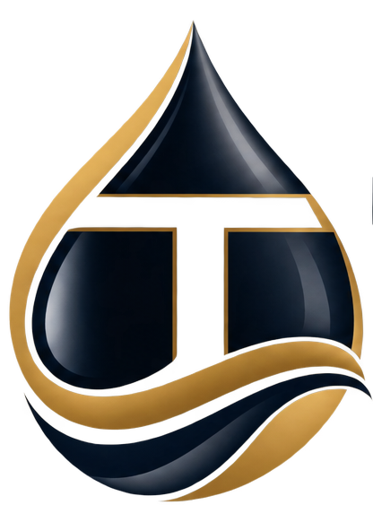
TERK ENERGY
Company Profile

An indigenous integrated energy services company working across the Nigerian oil and gas value chain, offshore and onshore.
EMAIL | info@terkenergy.com
TELEPHONE | +234 817 014 1009
TELEPHONE | +234 813 661 5889
WEB | www.terkenergy.com

An indigenous integrated energy company
Terk Energy serves the Nigerian oil and gas value chain, offshore and onshore. Our offering covers engineering, procurement, construction, installation and commissioning; the operation, maintenance and upgrade of oil and gas facilities; alternative crude evacuation; maritime and logistics solutions; and asset development.
Terk and its affiliates are committed to safety and to sustainability, and we continue to meet the demands of our clients efficiently: on schedule, to specification, and without shortcuts on either count.
Our experience, our strategic partnerships and our understanding of the Nigerian oil and gas value chain, offshore and onshore, equip us with the technical expertise and the resources to deliver diverse projects when given the opportunity.

Vision
To be a leading integrated energy service provider in Africa.

Mission
Our mission is to create a reputable organization through hard work and diligence, whilst making a positive impact on our community and our environment.

Our core values
Five commitments that decide how we take on work and how we behave once we have it.
Teamwork. We win together, leveraging diverse strengths for collective success.
Excellence. We hold ourselves to the highest standards in everything we do.
Customer obsession. We put our clients at the centre, always seeking to exceed expectations.
Ownership. We take responsibility, act with integrity, and deliver on our commitments.
Innovation. We constantly improve, adapt, and pioneer better solutions.

How the company is organised
Delivery, assurance and commercial functions are held in-house rather than assembled per project.
- EPC project management
- Engineering and construction leadership
- Procurement
- EHSSQ
- Vessel operations
- Shipping and chartering
- Gas and commercial analysis
- Finance, tax and project accounting
- Legal and corporate services
- Administration and human resources

Three service lines, one point of responsibility
One point of responsibility across engineering and construction, marine and logistics, and advisory. Each line below lists what we actually take on, along with our technical partners.

EPCIC Services

Engineering, procurement, construction, installation and commissioning. We take fixed-scope responsibility on onshore and offshore facilities, from front-end design through to handover, and carry procurement and construction with it.
SCOPE OF WORK
- FEED and detailed engineering design
- Pipeline construction and maintenance
- Procurement of OCTG, wellheads and pumps
- Structural, civil and mechanical engineering and construction
- Heavy-duty equipment supply, installation and maintenance
- Upgrade of onshore and offshore production facilities
- Clean energy solutions

Marine & Logistics Services
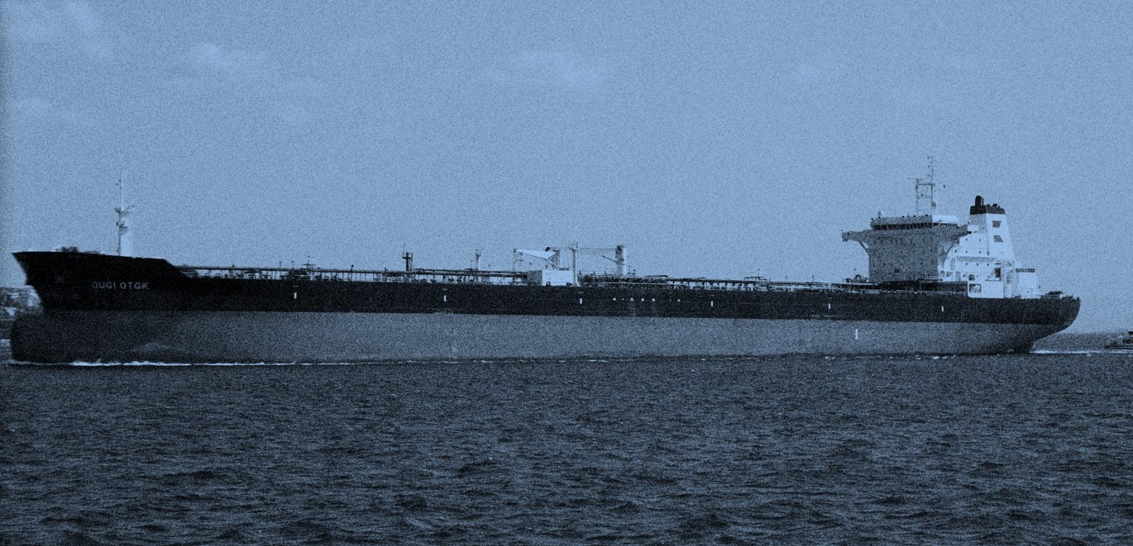
We move crude and cargo. Our Alternative Crude Evacuation System runs end to end, covering regulatory and naval clearance, security, shuttle tanker, ship-to-ship transfer into the mother vessel, and hydrocarbon accounting, all under a single point of responsibility rather than a chain of separate vendors.
SCOPE OF WORK
- Alternative Crude Evacuation System (ACES)
- Marine vessel supply and operations
- Offshore construction and installation
- Offshore operations support services
- Land and marine logistics support
- Hydrocarbon accounting

Advisory & Consultancy Services

Technical and commercial judgement for assets and transactions. We advise on asset development, run due diligence across the technical, commercial and regulatory dimensions, and structure gas commercialization.
SCOPE OF WORK
- Asset development advisory and consulting
- Technical, commercial and regulatory due diligence
- Tailored end-to-end alternative crude evacuation solutions
- Gas commercialization

What our engagements involve
These describe the shape of the work we are set up to take. They are capability, not a claim about any particular contract.
Tubular procurement package. Procurement of casing or tubing to a stated grade, weight and range for a drilling programme. Our scope runs across manufacture with the OEM partner, factory acceptance testing, shipping, in-country clearing, and logistics through to delivery at the client's facility, with project execution and the delivery schedule on our side of the line.
Alternative crude evacuation campaign. Evacuating crude from a field without pipeline access, using a shuttle tanker and a ship-to-ship transfer into a mother vessel. End to end this covers port and naval clearance, security cover, the marine spread, the transfer itself, hydrocarbon accounting and advisory through to reconciliation.
Land and marine logistics support. Sustained logistics for a producing asset or a construction campaign: crew and supply vessel provision, marine coordination, and the land-side movement that has to meet it. Measured on availability and turnaround rather than on mobilisation.

How the work is carried
Scope. We take defined scope with a defined interface. Where we are a sub-contractor, we say so; where we hold the whole package, we hold the schedule, the procurement and the site with it.
Partners. Original equipment manufacturers and technical partners are named into the scope from the outset rather than found once the contract is signed.
Assurance. Factory acceptance testing, inspection and quality hold points are planned into the programme, not bolted on at the end.

Our HSSE commitment
Terk Energy demonstrates leadership and commitment to HSE by the proper allocation of time and resources to HSES matters, and by giving HSES equal priority with work completion and milestone achievement. Our leadership commits as follows.
- Provide a safe work environment, and high quality, safe equipment for the work.
- Make financial resources available for the purchase of personal protective equipment.
- Employ qualified staff, and train staff in HSES.
- Take part in HSES policy formulation, and in HSES review meetings, audits and inspections.
- Promote an HSES culture throughout company communications.
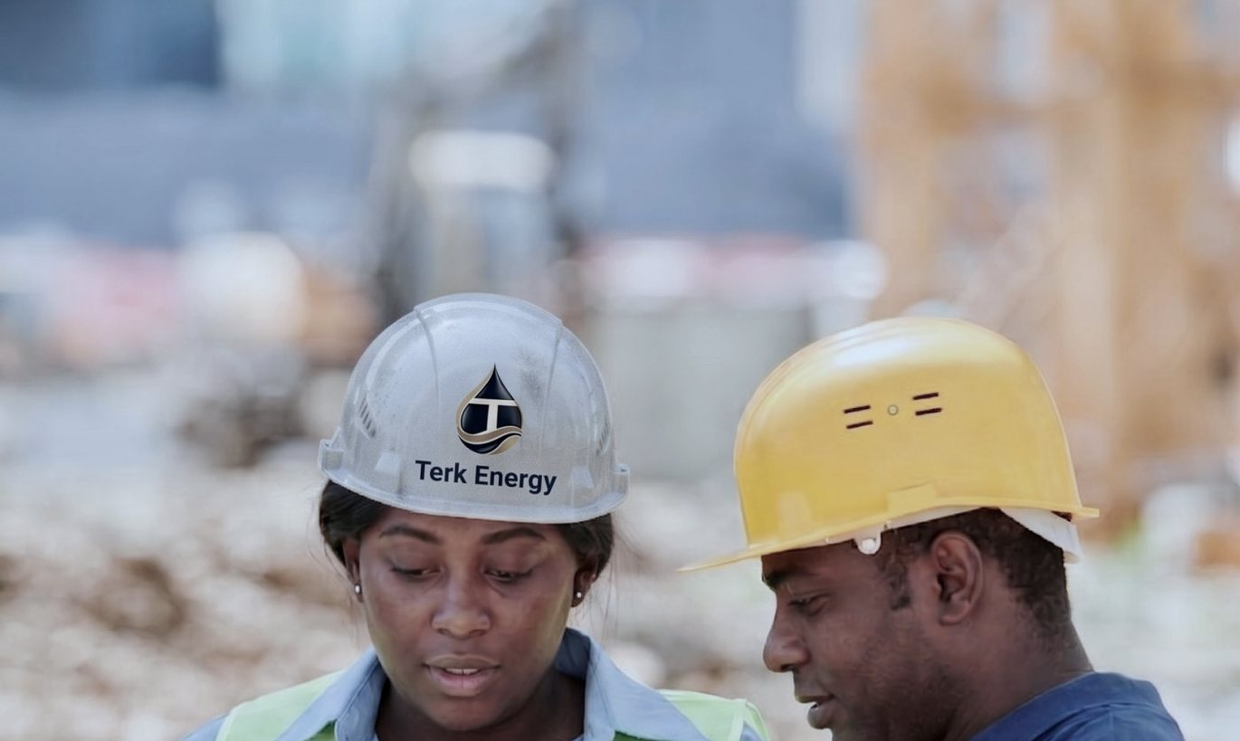

Our quality commitment
Our primary goal is to achieve the highest standards of quality in all our business practices and operations, without compromise. We are committed to ensuring that our work processes and business activities meet standards and exceed expectations for the quality and satisfaction of all interested parties. To this end, we shall:
- Sustain a process approach, where regular monitoring of system performance, factual analysis and market feedback are the basis for effective decision-making and continual improvement.
- Foster mutually beneficial relationships with business partners.
- Evaluate quality risks, managed as an integral part of the system, to ensure services and output are fit for purpose.
- Identify and comply with applicable legal and regulatory requirements.
- Ensure that adequate resources are provided for the implementation and maintenance of our quality management system.
If you are running a pre-qualification and need our HSE plan, quality manual or policy statements, ask and we will send them.

Tell us about your project
Send us your tender document, scope of work, or the problem you need solved. We will review it and respond with a clear answer on how we can support you, and tell you who will be handling it.
EMAIL | info@terkenergy.com
TELEPHONE | +234 817 014 1009
TELEPHONE | +234 813 661 5889
WEB | www.terkenergy.com

